**Newton Raphson Method**

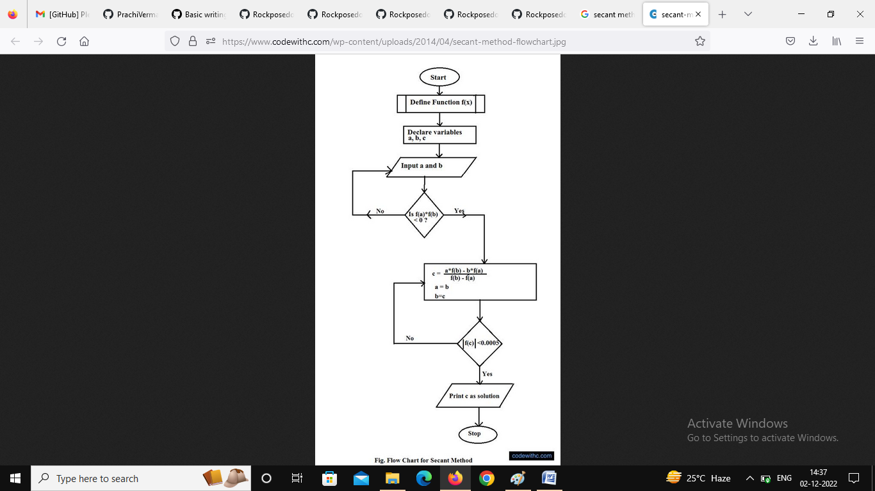

**Algorithm for Secant Method**

1. Start
2. Get values of x0, x1 and e(Here x0 and x1 are the two initial guesses, e is the stopping criteria, absolute error or the desired degree of accuracy)
3. Compute f(x0) and f(x1)
4. Compute x2 = [x0*f(x1) – x1*f(x0)] / [f(x1) – f(x0)]
5. Test for accuracy of x2  
    If [ (x2 – x1)/x2 ] > e, (Here [ ] is used as modulus sign)  
    then assign x0 = x1 and x1 = x2  
    goto step 4  
   Else,  
    goto step 6
6. Display the required root as x2.
7. Stop